Topic 9: ‘International conflicts and crises in the 20th century (I) – the two world wars’
Case study: War and Inventions—Medicine
Activity 2: War and Medicine
Students are divided into 4 groups, and complete the related learning activity.

Group One
You are a medical worker stationed at a medical station. Study the information of a wounded soldier in Source A and respond to the related assessment form.

Source A: The following table is about the information of a wounded soldier who was sent to the medical station.
Information of the wounded soldier |  | Related photo
Date of injury | 5 / 8 / 1916 | 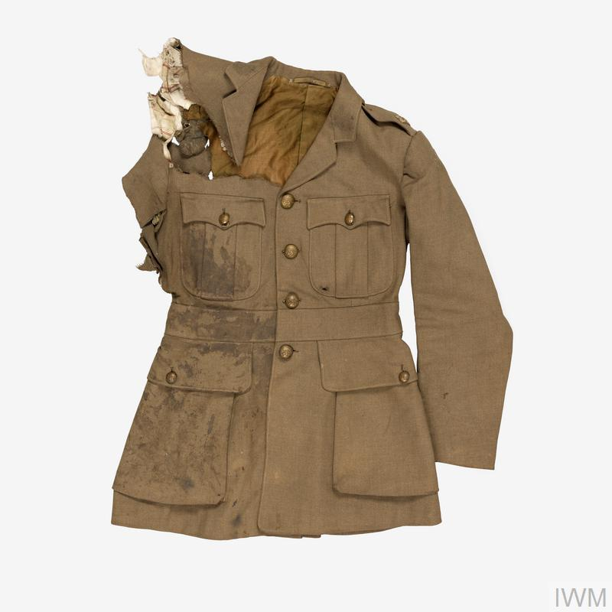  © IWM UNI 10830
Injury site | River of Somme
Injured part | Right arm
Main injury | Shot in the right shoulder  Right arm cannot move  Heavy bleeding
Source: https://www.iwm.org.uk/history/second-lieutenant-harold-cope

- Fill in the following table according to the needs of the wounded soldier:
Medical items | X-ray machine | ambulance | blood transfusion | Thomas splint | reconstructive surgery | psychological treatment
In need
（/ X）

- Give a brief explanation of the item(s) that is assessed as ‘need’ in（a）and on how it can help the wounded soldier for follow up afterwards.

Group Two
You are a medical worker stationed at a medical station. Study the information of the wounded soldiers in Source B and respond to the related assessment form.

Source B: The following is about the information of the wounded soldiers who were sent to the medical station.
Information of the wounded soldiers |  | Related photo
Date of injury | 22 / 4 / 1915 | 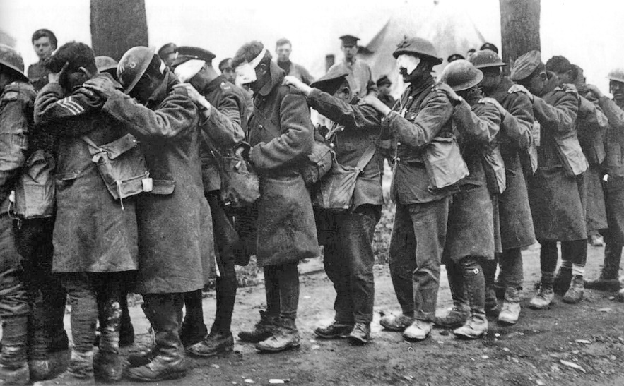  （related photo of poison gas attack) Thomas Keith Aitken (Second Lieutenant), Public domain, via Wikimedia Commons
Injury site | Ypres
Injured part | Eyes, respiratory system
Main injury | Blindness  Severe pain in the eye  Difficulty in breathing
Source: https://www.iwm.org.uk/history/voices-of-the-first-world-war-gas-attack-at-ypres

- Fill in the following table according to the needs of the wounded soldiers:
Medical items | X-ray machine | ambulance | blood transfusion | Thomas splint | reconstructive surgery | psychological treatment
In need
（/ X）

- Give a brief explanation of the item(s) that is assessed as ‘need’ in（a）and on how it can help the wounded soldiers for follow up afterwards.

Group Three
You are a medical worker stationed in a medical station. Study the information of a wounded soldier in Source C and respond to the related assessment form.

Source C: The following is the information of a wounded soldier who was sent to the medical station.
Information of the wounded soldier |  | Related photo
Date of injury | 15 / 2 / 1945 | 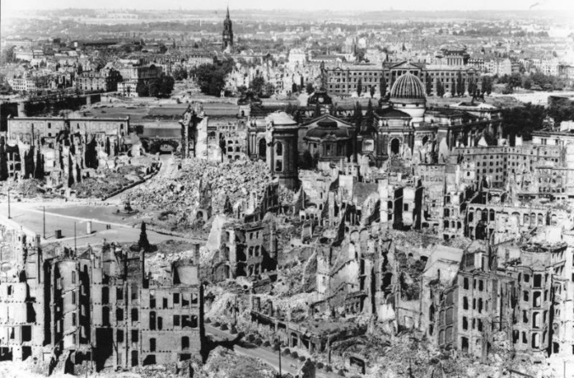  （Bombing of Dresden）Bundesarchiv, Bild 146-1994-041-07 / Unknown author Unknown author / CC-BY-SA 3.0, CC BY-SA 3.0 DE <https://creativecommons.org/licenses/by-sa/3.0/de/deed.en>, via Wikimedia Commons
Injury site | Dresden
Injured part | Skin, respiratory system, right leg
Main injury | Severe burns  Difficulty in breathing  Bone fracture in right leg

- Fill in the following table according to the needs of the wounded soldier:
Medical items | X-ray machine | ambulance | blood transfusion | Thomas splint | reconstructive surgery | psychological treatment
In need
（/ X）

- Give a brief explanation of the item(s) that is assessed as ‘need’ in（a）and on how it can help the wounded soldier for follow up afterwards.

Group Four
You are a medical worker stationed in a medical station. Study the information of the injured persons in Source D and respond to the related assessment form.

Source D: The following is the information of the injured persons who were sent to the medical station.
Information of the injured persons |  | Related picture
Date of injury | 15 / 8 / 1945 | 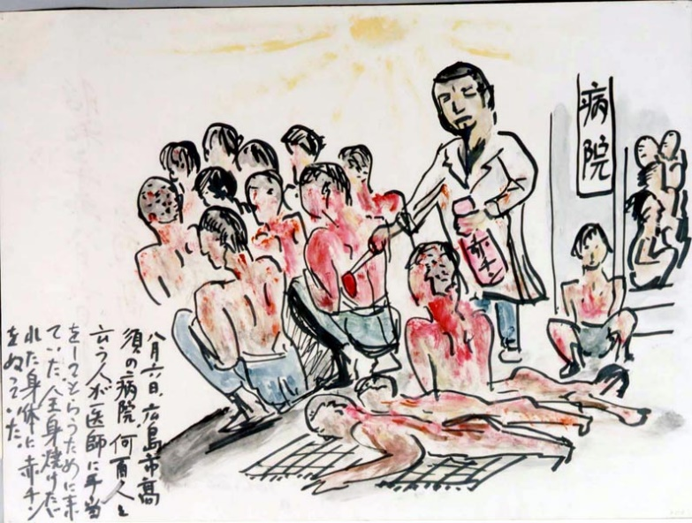  （atomic bombing in Hiroshima）  https://visualizingcultures.mit.edu/groundzero1945/gallery/pages/16_07.htm
Injury site | Hiroshima
Injured part | skin
Main injury | Severe burns

- Fill in the following table according to the needs of the injured persons：
Medical items | X-ray machine | ambulance | blood transfusion | Thomas splint | reconstructive surgery | psychological treatment
In need
（/ X）

- Give a brief explanation of the item(s) that is assessed as ‘need’ in（a）and on how it can help the injured persons for follow up afterwards.

Topic 9: ‘International conflicts and crises in the 20th century (I) – the two world wars’
Case study: War and Inventions—Medicine
Activity 2: War and Medicine
Students are divided into 4 groups, and complete the related learning activity.

Group One
You are a medical worker stationed at a medical station. Study the information of a wounded soldier in Source A and respond to the related assessment form.

Source A: The following table is about the information of a wounded soldier who was sent to the medical station.
Information of the wounded soldier |  | Related photo
Date of injury | 5 / 8 / 1916 | © IWM UNI 10830
Injury site | River of Somme
Injured part | Right arm
Main injury | Shot in the right shoulder  Right arm cannot move  Heavy bleeding
Source: https://www.iwm.org.uk/history/second-lieutenant-harold-cope

- Fill in the following table according to the needs of the wounded soldier:
Medical items | X-ray machine | ambulance | blood transfusion | Thomas splint | reconstructive surgery | psychological treatment
In need  （/ X） |  |  |  |  | x | 

- Give a brief explanation of the item(s) that is assessed as ‘need’ in（a）and on how it can help the wounded soldier for follow up afterwards.
- X-ray machine – to understand the injury, so as to find a suitable treatment plan for the wounded soldier.
- Ambulance – to transport the wounded who need immediate treatment to hospitals.
- Blood transfusion – enable over-bleeding soldiers to have a higher chance of survival.
- Thomas splint – to stabilize the injured part, so as to avoid unnecessary amputation of soldiers.
- Psychological treatment – to soothe soldiers / civilians that suffered from mental injury / breakdown.

Group Two
You are a medical worker stationed at a medical station. Study the information of the wounded soldiers in Source B and respond to the related assessment form.

Source B: The following is about the information of the wounded soldiers who were sent to the medical station.
Information of the wounded soldiers |  | Related photo
Date of injury | 22 / 4 / 1915 | （related photo of poison gas attack) Thomas Keith Aitken (Second Lieutenant), Public domain, via Wikimedia Commons
Injury site | Ypres
Injured part | Eyes, respiratory system
Main injury | Blindness  Severe pain in the eye  Difficulty in breathing
Source: https://www.iwm.org.uk/history/voices-of-the-first-world-war-gas-attack-at-ypres

- Fill in the following table according to the needs of the wounded soldiers:
Medical items | X-ray machine | ambulance | blood transfusion | Thomas splint | reconstructive surgery | psychological treatment
In need  （/ X） | x |  | x | x | x | 

- Give a brief explanation of the item(s) that is assessed as ‘need’ in（a）and on how it can help the wounded soldiers for follow up afterwards.

- Ambulance – to transport the wounded who need immediate treatment to hospitals.
- Psychological treatment – to soothe soldiers / civilians that suffered from mental injury / breakdown.

Group Three
You are a medical worker stationed in a medical station. Study the information of a wounded soldier in Source C and respond to the related assessment form.

Source C: The following is the information of a wounded soldier who was sent to the medical station.
Information of the wounded soldier |  | Related photo
Date of injury | 15 / 2 / 1945 | （Bombing of Dresden）Bundesarchiv, Bild 146-1994-041-07 / Unknown author Unknown author / CC-BY-SA 3.0, CC BY-SA 3.0 DE <https://creativecommons.org/licenses/by-sa/3.0/de/deed.en>, via Wikimedia Commons
Injury site | Dresden
Injured part | Skin, respiratory system, right leg
Main injury | Severe burns  Difficulty in breathing  Bone fracture in right leg

- Fill in the following table according to the needs of the wounded soldier:
Medical items | X-ray machine | ambulance | blood transfusion | Thomas splint | reconstructive surgery | psychological treatment
In need  （/ X） |  |  | x |  |  | 

- Give a brief explanation of the item(s) that is assessed as ‘need’ in（a）and on how it can help the wounded soldier for follow up afterwards.

- X-ray machine – to understand the injury, so as to find a suitable treatment plan for the wounded soldier.
- Ambulance – to transport the wounded who need immediate treatment to hospitals.
- Thomas splint – to stabilize the injured part, so as to avoid unnecessary amputation of soldiers.
- Reconstructive surgeries – restore part of the facial functions of soldiers who were disfigured.
- Psychological treatment – to soothe soldiers / civilians that suffered from mental injury / breakdown.

Group Four
You are a medical worker stationed in a medical station. Study the information of the injured persons in Source D and respond to the related assessment form.

Source D:The following is the information of the injured persons who were sent to the medical station.
Information of the injured persons |  | Related picture
Date of injury | 15 / 8 / 1945 | （atomic bombing in Hiroshima）  https://visualizingcultures.mit.edu/groundzero1945/gallery/pages/16_07.htm
Injury site | Hiroshima
Injured part | skin
Main injury | Severe burns

- Fill in the following table according to the needs of the injured persons：
Medical items | X-ray machine | ambulance | blood transfusion | Thomas splint | reconstructive surgery | psychological treatment
In need  （/ X） | x |  | x | x |  | 

- Give a brief explanation of the item(s) that is assessed as ‘need’ in（a）and on how it can help the injured persons for follow up afterwards.

- Ambulance – to transport the wounded who need immediate treatment to hospitals.
- Reconstructive surgeries – restore part of the facial functions of wounded who were disfigured.
- Psychological treatment – to soothe soldiers / civilians that suffered from mental injury / breakdown.

